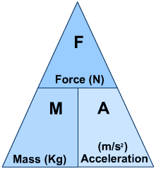
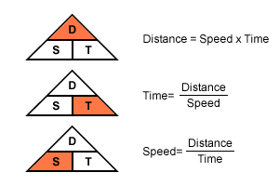
Formulae you might need:

F = m x a v = u +at

V_{av} = s Wt = m x g
t

a = v-u g = 9.8 m s⁻²
t

Ep= m x g x h E_{k}= ½ m v²

There are 1000 m in a km.
There are 3600 s in an hr.

ɳ= useful output x 100
input

Ep= mgh Ek= ½ mv²

